**RTPD**

# Introduction

This paper examines motor skill learning. Motor learning involves implicit memory, meaning that participants (Ps) can theoretically learn the cue pattern without conscious awareness of it (Radvansky & Ashcraft, 2014). The experiment tests this type of learning by measuring response time (RT) for cues which repeat a sequence every block except for each fifth. If implicit learning has occurred, one would expect lower RT for the fixed patterns (Ashby & O’brien, 2005).

Further, it is expected that the positions part of the experiment will produce shorter RTs as digits will have to be modally translated to provide the spatial cue for the correct response (Barsalou, 2008; Radvansky & Ashcraft, 2014).

# Method

This experiment included *N* = 218 Ps, all psychology students at UCPH. Age and sex differences were not considered.

## Materials

* Computer with E-Prime® files for RTPD
* Pen and paper

## Procedure

On screen approximately half of the Ps were shown four empty boxes, while the other half was shown a fixation cross. Cues were presented, consisting of either a dot in one of the boxes or a digit (1-4). Ps were tasked with indicating the position or digit by pressing keys on which their left and right middle and index fingers were placed, corresponding to the onscreen cue location. After completing 20 blocks of 24 cues the other experiment was completed. Between the two experiments, Ps were asked whether they had noticed a pattern in the cues.

Cues were shown for 500 ms and each block repeated a fixed sequence of positions or digits, only including random sequences every fifth block.

RT and accuracy (ACC) were measured. Statistical analysis was carried out using SPSS. Any analysis of RT considered only correct responses.

# Results

Figure 1 reveals a pattern in which the position condition has the lowest average RT, and the random sequences have a higher RT than the fixed ones. This supports the notion that Ps learn the sequence. There seems to be a strong initial learning phase as the first block has a markedly higher RT than all following in each condition.

Figure 1: Sequence learning for positions and digits as determined by RT

To test the significance of these observations a repeated measures ANOVA of blocks 1-4 was conducted.

It showed significant main effects of stimulus, *F*(1, 217) = 493.66, *p* < .001, $η_{p}^{2}$ = .70, and block, *F*(1.27, 276.49) = 91.50, *p* < .001, $η_{p}^{2}$ = .30 (Huyhn-Feldt corrected), and a significant interaction between stimulus and block, *F*(1.36, 294.76) = 5.96, *p* = .01, $η_{p}^{2}$ = .03.

This confirms that RT for the position condition is indeed significantly lower than for the digit condition. It also supports the notion that learning occurs during the experiment as the effect of block is significant. This effect may be caused by the contrast between random and fixed blocks. The effect varies between the stimulus types, as evident by the interaction, indicating that the initial learning phase differs in effectiveness (Figure 1).

## Positions provide more valid cues than digits

To determine whether the order in which Ps completed the experiments had a significant effect on RT, a repeated measures ANOVA was conducted.

It showed a significant main effect of stimulus, *F*(1, 216) = 97.52, *p* < .001, $η_{p}^{2}$ = .31, but no significant main effect of order, *F*(1, 216) = 1.06, *p* = .31, $η_{p}^{2}$ = .01. There was a significant interaction between the two, *F*(1, 216) = 13.32, *p* < .001, $η_{p}^{2}$ = .06.

This means that RT was generally lower in the positions condition regardless of which condition was completed first, suggesting that more modally valid cues are more effective in generating correct responses (Figure 2). The interaction implies a general practice effect.

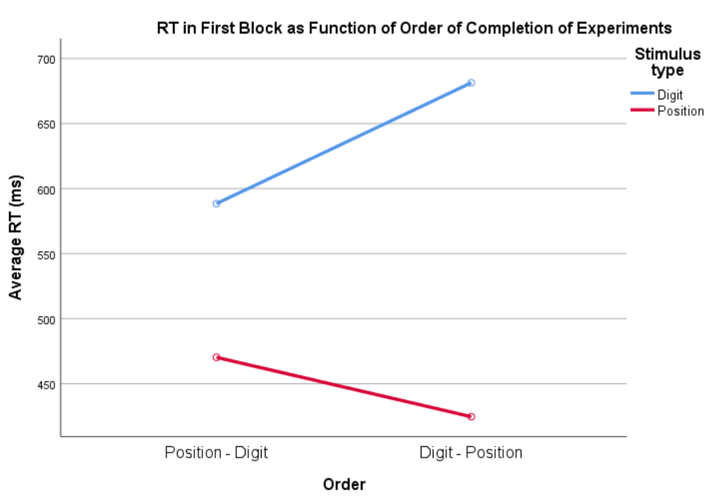

Figure 2: Training effect across tests

## Practice is a double-edged sword

To investigate the practice effect a repeated measures ANOVA considering only those sequences which were novel to the Ps was conducted. The first block has been included in the test as it is effectively random to the Ps.

The test showed significant main effects of stimulus, *F*(1, 217) = 764.71, *p* < .001, $η_{p}^{2}$ = .78, and block, *F*(1.59, 345.31) = 34.32, *p* < .001, $η_{p}^{2}$ = .14 (Huyhn-Feldt corrected), as well as a significant interaction between stimulus and block, *F*(1.59, 344.50) = 5.21, *p* = .01, $η_{p}^{2}$ = .02 (Huyhn-Feldt corrected).

Considering only the novel blocks, the difference in RT between position and digit stimuli continues to be significant. RT varies between blocks, likely representing the initial learning phase after the first block. A closer look reveals that RT increases in the random blocks, after the initial drop, suggesting that Ps must inhibit the trained response from the fixed blocks.

The effects interact, making the first block in the digits condition the one with the highest RT (Figure 2).

To test whether some Ps did better in the two experiments overall, a Pearsons correlation test was conducted.

It showed significant positive correlations between digit and position conditions for blocks 1 (fixed), *r*(216) = .22, *p* = .001, for blocks 19 (fixed), *r*(216) = .30, *p* < .001, and for blocks 20 (random), *r*(216) = .54, *p* < .001.

Ps who did well in one condition, also did well in the next, regardless of which block was measured. The correlation is stronger for random blocks, indicating individual differences.

## Tests of accuracy confirm findings

To test whether the result for RT would also be relevant when considering ACC, a repeated measures ANOVA of the effect of stimulus and sequence type on ACC was conducted.

The test showed significant main effects of stimulus, *F*(1, 217) = 30.26, *p* < .001, $η_{p}^{2}$ = .12, and sequence type, *F*(1, 217) = 133.31, *p* < .001, $η_{p}^{2}$ = .38, but no significant interaction between stimulus and sequence type, *F*(1, 217) = 3.10, *p* = .08, $η_{p}^{2}$ = .01.

In accordance with RT results, the position condition has significantly fewer errors than the digit position. Further, the fixed sequences showed fewer errors than the random ones (Figure 3).

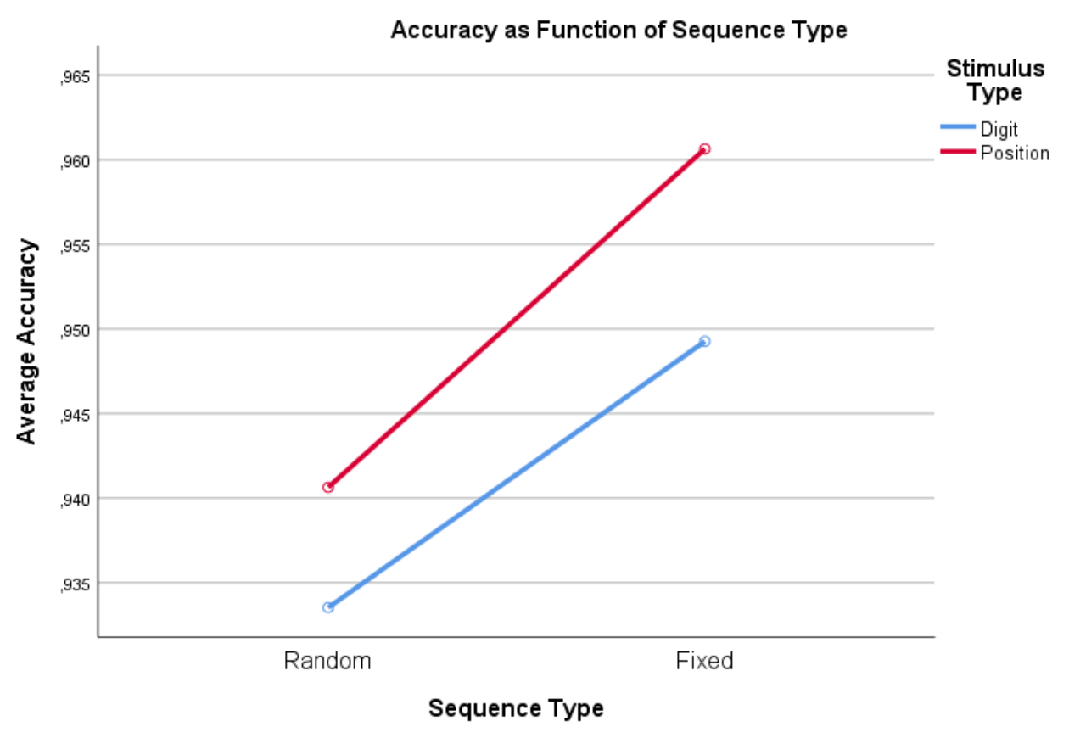

Figure 3: Accuracy for sequence and stimulus type

## Both conditions have a speed-accuracy trade-off

A two-tailed Pearsons correlation showed significant positive correlation between accuracy and RT in block 20 for both digit, *r*(216) = .28, *p* < .001, and position conditions, *r*(216) = .36, *p* < .001, meaning that there is a speed-accuracy trade-off for both conditions.

## Differential practice benefit

A closer look at the individual plot for FP19201 (Figure 4) reveals a pattern similar to the average of the sample. FP19201 shows an improving RT throughout the experiment and displays the difference in RT between stimulus conditions. In the digits condition the hierarchy in RT of random and fixed blocks is less pronounced, perhaps indicating that implicit learning is more effective in the positions condition.

Figure 4: Sequence learning for FP19201

# Conclusion

This experiment provides evidence that implicit learning occurs from repeating a motor sequence and that this learnt improvement in RT can be carried across to different stimulus types. Further, it supports the notion that motor reactions are quicker when the stimulus itself provides a valid cue to the correct response than when the stimulus must be modally translated to determine the response.

# References

Ashby, F. G., & O’brien, J. B. (2005). Category learning and multiple memory systems. *TRENDS in Cognitive Sciences*, *9*(2), 83–89.

Barsalou, L. W. (2008). Grounded Cognition. *Annual Review of Psychology*, *59*, 617–645.

Radvansky, G. A., & Ashcraft, M. H. (2014). *Cognition* (6th ed.). Upper Saddle River: Pearson Education.